

**UNIVERSITY OF ASIA PACIFIC**

**Department of CSE**

**Course Code:** **CSE 212**

**Course Title:** **Database Systems Lab**

**Project Name: Export and Import Management System**

**Submitted By:**

#### Md. Samimul Arefin - 23101029

#### Sanjida Siddiqa Mahima - 23101030

#### Mysha - 23101048

#### Nowshin Rahman Omi - 23101050

**Submitted to:**

**Nadeem Ahmed**

**Assistant Professor**

**Department of CSE**

**University of Asia Pacific**

**Export and Import Management System**

**1.Descripsion:**

This database management system is designed to track and manage export and import operations for an international trading company. It handles information about products, suppliers, customers, shipments, orders, inventory, and documentation required for international trade.

**Core Functionality:**

**Product Management**

* Comprehensive product catalog with detailed specifications and classifications
* Multi-supplier sourcing with price comparisons and lead time tracking
* Product certification and compliance documentation
* Country of origin tracking and rules of origin verification
* Product quality control metrics and inspection histories
* Custom tariff code assignment and duty calculation

**Supply Chain Management**

* End-to-end tracking from manufacturer to end customer
* Multi-modal transportation management (sea, air, road, rail)
* Container and pallet tracking with load optimization
* Port and customs clearance processing
* Transit time monitoring and exception alerts
* Freight cost management and carrier performance analytics

**Documentation Management**

* Automatic generation of commercial invoices and packing lists
* Certificate of origin creation and validation
* Import/export license management
* Customs declaration preparation
* Letter of credit compliance checking
* Harmonized System (HS) code verification
* Sanitary and phytosanitary certification

**Inventory Control**

* Real-time inventory visibility across global warehouses
* FIFO/LIFO/FEFO inventory valuation methods
* Lot and batch tracking with expiration date management
* Stock level alerts and automated reordering
* Warehouse capacity optimization
* Bonded warehouse handling for duty deferment
* Inventory aging analysis and obsolescence prevention

**Order Processing**

* Multi-currency order management
* International payment terms (FOB, CIF, EXW, DDP, etc.)
* Order consolidation for optimized shipping
* Split shipment handling and partial fulfillment
* Automated duty and tax calculation
* Customer-specific pricing and discount structures
* Order status tracking and notification system

**Compliance & Risk Management**

* Export control screening against denied party lists
* Embargo and sanctions compliance checking
* Import quota monitoring and license management
* Trade agreement qualification and preferential duty calculation
* Product safety and compliance documentation
* Supply chain risk assessment

**Financial Operations**

* Multi-currency invoicing and payment processing
* Exchange rate management and hedging
* Trade finance integration (letters of credit, bank guarantees)
* Landed cost calculation (product + freight + insurance + duties + taxes)
* Customs bond management
* Duty drawback and VAT recovery tracking

**Business Intelligence**

* Trade volume analytics by country, product, and customer
* Margin analysis accounting for all international trade costs
* Supply chain performance metrics and KPIs
* Compliance risk dashboards
* Market penetration and growth opportunity analysis
* Landed cost optimization recommendations
* Carrier performance and freight cost benchmarking

**2.Entities and Their Relationships**

### Entities:

**1. Products**  
  
Primary Key: product_id  
Attributes: product_name, unit_price, packaging, supplier_id  
Represents inventory items sold by the company  
  
  
**2. Suppliers**  
  
Primary Key: supplier_id  
Attributes: contact_person, email, phone_number  
Represents vendors who provide products to the company  
  
  
**3. Packaging**  
  
Primary Key: packaging_id  
Attributes: packaging_type, unit_capacity, weight_capacity  
Represents different packaging options for products  
  
  
**4. Orders**  
  
Primary Key: order_id  
Attributes: order_date, customer_id, product_id, units, country_id  
Represents customer purchases  
  
  
**5. Countries**  
Primary Key: country_id  
Attributes: country_name, import_tax, export_tax  
Represents geographical locations for shipping and regulatory purposes

**6. Warehouses**  
Primary Key: warehouse_id  
Attributes: warehouse_name, location, capacity, country_id, administration_id  
Represents physical storage locations

**7. Employees**  
  
Primary Key: employee_id  
Attributes: employee_name, gender, administration_id, salary, email, phone_number, supervisor_id, joining_date  
Represents staff members  
  
  
**8. Supervisors**  
  
Primary Key: supervisor_id  
Attributes: supervisor_name, gender, administration_id, salary, email, phone_number, joining_date  
Represents employees with management responsibilities  
  
  
**9. Administration**  
  
Primary Key: administration_id  
Attributes: administration_name, administration_work  
Represents organizational departments or divisions  
  
  
**10. ImportDocument**  
  
Primary Key: document_id  
Attributes: document_type, authority_id, validity_period  
Represents documentation for imported goods  
  
**11. ExportDocument**  
  
Primary Key: document_id  
Attributes: document_type, authority_id, validity_period  
Represents documentation for exported goods

**Relationships:**

### 1. Products - Suppliers (Supply)

### One-to-many: A supplier can provide multiple products

### Foreign Key: supplier_id in Products references Suppliers

### 2. Products - Packaging (Packaging Category)

### One-to-many: A packaging type can be used for multiple products

### Foreign Key: packaging_id in Products references Packaging

### 3. Products - Orders (Shipments)

### One-to-many: A product can appear in multiple orders

### Foreign Key: product_id in Orders references Products

### 4. Orders - Countries (Belong)

### One-to-many: A country can be associated with multiple orders

### Foreign Key: country_id in Orders references Countries

### 5. Countries - Warehouses (Stocks)

### One-to-many: A country can have multiple warehouses

### Foreign Key: country_id in Warehouses references Countries

### 6. Warehouses - Administration (Inventory)

### Many-to-one: Multiple warehouses can be managed by an administration

### Foreign Key: administration_id in Warehouses references Administration

### 7. Employees - Administration (Works)

### Many-to-one: Multiple employees can work in an administration

### Foreign Key: administration_id in Employees references Administration

### 8. Supervisors - Administration (Works)

### Many-to-one: Multiple supervisors can work in an administration

### Foreign Key: administration_id in Supervisors references Administration

### 9. Administration - ImportDocument (Import)

### One-to-many: An administration can be associated with multiple import documents

### Foreign Key: authority_id in ImportDocument references Administration

### 10. Administration - ExportDocument (Export)

### One-to-many: An administration can be associated with multiple export documents

### Foreign Key: authority_id in ExportDocument references Administration

### 11. Supervisors - Employees (Leads)

### One-to-many: A supervisor can lead multiple employees

### Foreign Key: supervisor_id in Employees references Supervisors

**3. ER Diagram**

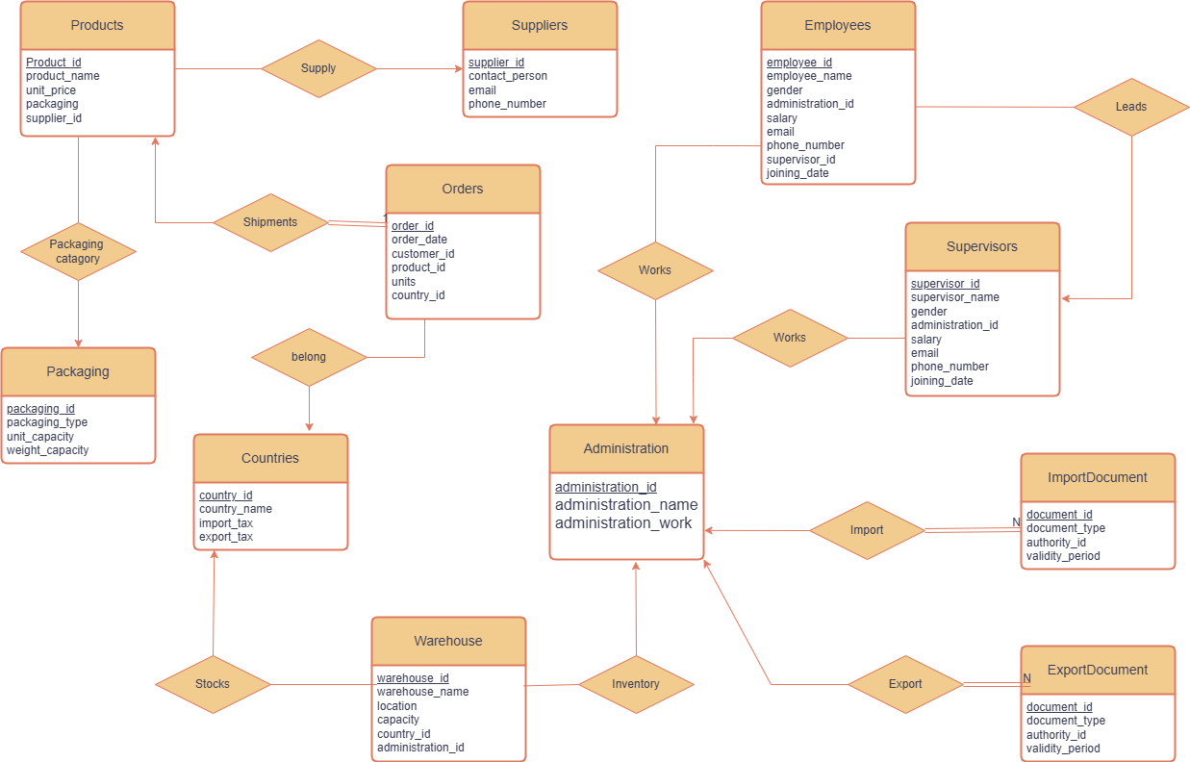

**4.Schema Diagram**

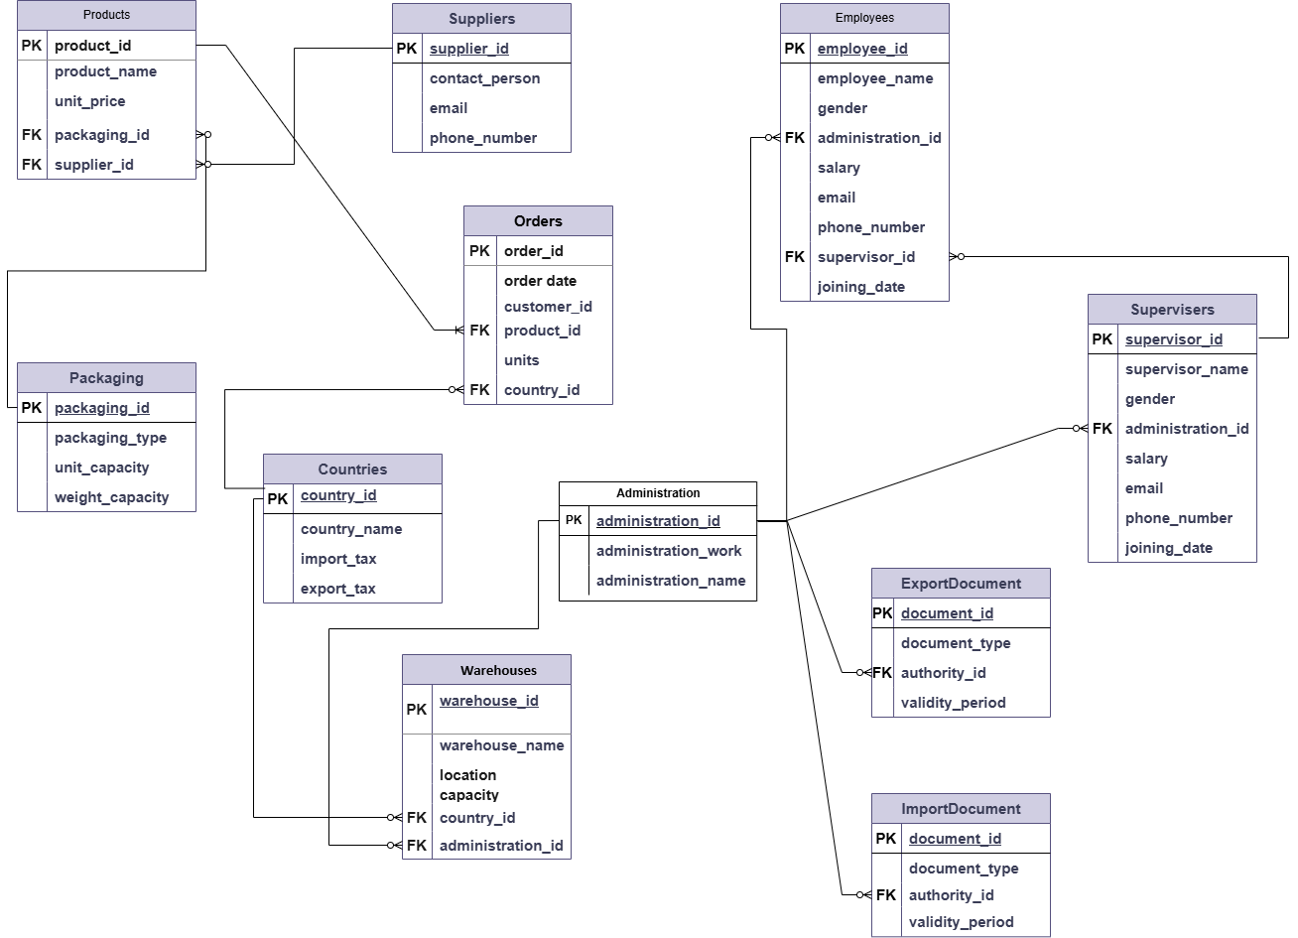

**5.SQL Code:**

**TABLE CREATE-**

CREATE DATABASE exportandimport

USE exportandimport

CREATE TABLE Suppliers (

supplier_id INT PRIMARY KEY,

contact_person VARCHAR(100),

email VARCHAR(100),

phone_number VARCHAR(20)

)

-- Create Packaging table

CREATE TABLE Packaging (

packaging_id INT PRIMARY KEY,

packaging_type VARCHAR(50),

unit_capacity DECIMAL(10,2),

weight_capacity DECIMAL(10,2)

)

-- Create Products table

CREATE TABLE Products (

product_id INT PRIMARY KEY,

product_name VARCHAR(100),

unit_price DECIMAL(10,2),

packaging_id INT FOREIGN KEY

REFERENCES Packaging,

supplier_id INT FOREIGN KEY

REFERENCES Suppliers

)

-- Create Countries table

CREATE TABLE Countries (

country_id INT PRIMARY KEY,

country_name VARCHAR(100),

import_tax DECIMAL(5,2),

export_tax DECIMAL(5,2)

)

-- Create Administration table

CREATE TABLE Administration (

administration_id INT PRIMARY KEY,

administration_name VARCHAR(100),

administration_work VARCHAR(200)

)

-- Create Supervisors table

CREATE TABLE Supervisors (

supervisor_id INT PRIMARY KEY,

supervisor_name VARCHAR(100),

gender CHAR(1),

administration_id INT FOREIGN KEY

REFERENCES Administration,

salary DECIMAL(10,2),

email VARCHAR(100),

phone_number VARCHAR(20),

joining_date DATE

)

-- Create Employees table

CREATE TABLE Employees (

employee_id INT PRIMARY KEY,

employee_name VARCHAR(100),

gender CHAR(1),

administration_id INT FOREIGN KEY

REFERENCES Administration,

salary DECIMAL(10,2),

email VARCHAR(100),

phone_number VARCHAR(20),

supervisor_id INT FOREIGN KEY

REFERENCES Supervisors,

joining_date DATE

)

-- Create Warehouse table

CREATE TABLE Warehouse (

warehouse_id INT PRIMARY KEY,

warehouse_name VARCHAR(100),

location VARCHAR(200),

capacity INT,

country_id INT,

administration_id INT FOREIGN KEY

REFERENCES Administration,

FOREIGN KEY (country_id) REFERENCES Countries(country_id)

)

-- Create ImportDocument table

CREATE TABLE ImportDocument (

document_id INT PRIMARY KEY,

document_type VARCHAR(50),

authority_id INT FOREIGN KEY

REFERENCES Administration(administration_id),

validity_period DATE

)

-- Create ExportDocument table

CREATE TABLE ExportDocument (

document_id INT PRIMARY KEY,

document_type VARCHAR(50),

authority_id INT FOREIGN KEY

REFERENCES Administration(administration_id),

validity_period DATE

)

-- Create Orders table

CREATE TABLE Orders (

order_id INT PRIMARY KEY,

order_date DATE,

customer_id INT,

product_id INT,

units INT,

country_id INT,

FOREIGN KEY (product_id) REFERENCES Products(product_id),

FOREIGN KEY (country_id) REFERENCES Countries(country_id)

)

**INSERT DATA IN TABLE-**

-- Suppliers  
INSERT INTO Suppliers VALUES  
(1, 'Alice Johnson', '[alice@example.com](mailto:alice@example.com)', '1234567890'),  
(2, 'Bob Smith', '[bob@example.com](mailto:bob@example.com)', '2345678901'),  
(3, 'Carlos Ruiz', '[carlos@example.com](mailto:carlos@example.com)', '3456789012'),  
(4, 'Diana Lee', '[diana@example.com](mailto:diana@example.com)', '4567890123'),  
(5, 'Evan Thomas', '[evan@example.com](mailto:evan@example.com)', '5678901234'),  
(6, 'Fiona Zhang', '[fiona@example.com](mailto:fiona@example.com)', '6789012345'),  
(7, 'George Patel', '[george@example.com](mailto:george@example.com)', '7890123456');  
  
-- Packaging  
INSERT INTO Packaging VALUES  
(1, 'Box', 10.00, 50.00),  
(2, 'Bag', 5.00, 20.00),  
(3, 'Crate', 15.00, 100.00),  
(4, 'Envelope', 1.00, 1.00),  
(5, 'Tube', 2.50, 5.00),  
(6, 'Canister', 12.00, 60.00),  
(7, 'Bottle', 0.75, 1.50),  
(8, 'Drum', 50.00, 200.00);  
  
-- Products  
INSERT INTO Products VALUES  
(1, 'Laptop', 1500.00, 1, 1),  
(2, 'Phone', 800.00, 2, 2),  
(3, 'Tablet', 600.00, 3, 3),  
(4, 'Monitor', 300.00, 4, 4),  
(5, 'Keyboard', 50.00, 5, 5),  
(6, 'Mouse', 25.00, 6, 6),  
(7, 'Headphones', 75.00, 7, 7),  
(8, 'Webcam', 90.00, 8, 1);  
  
-- Countries  
INSERT INTO Countries VALUES  
(1, 'USA', 5.00, 3.00),  
(2, 'Germany', 6.00, 4.00),  
(3, 'India', 7.00, 5.00),  
(4, 'Brazil', 8.00, 6.00),  
(5, 'Canada', 4.00, 2.00),  
(6, 'Japan', 3.50, 2.50),  
(7, 'Australia', 5.50, 3.50),  
(8, 'UK', 4.25, 2.75);  
  
-- Administration  
INSERT INTO Administration VALUES  
(1, 'Logistics', 'Manage logistics and operations'),  
(2, 'HR', 'Handle human resources'),  
(3, 'Finance', 'Manage company finances'),  
(4, 'Procurement', 'Handle supplier relations'),  
(5, 'IT', 'Maintain IT systems'),  
(6, 'Legal', 'Ensure compliance'),  
(7, 'Marketing', 'Brand and promote'),  
(8, 'Operations', 'Oversee operations');  
  
-- Supervisors  
INSERT INTO Supervisors VALUES  
(1, 'John Doe', 'M', 1, 75000.00, '[john@example.com](mailto:john@example.com)', '3456789012', '2020-01-15'),  
(2, 'Jane Smith', 'F', 2, 72000.00, '[jane@example.com](mailto:jane@example.com)', '4567890123', '2021-03-20'),  
(3, 'Mike Evans', 'M', 3, 71000.00, '[mike@example.com](mailto:mike@example.com)', '5678901234', '2021-08-10'),  
(4, 'Linda Kim', 'F', 4, 76000.00, '[linda@example.com](mailto:linda@example.com)', '6789012345', '2020-11-05'),  
(5, 'Sarah Connor', 'F', 5, 74000.00, '[sarah@example.com](mailto:sarah@example.com)', '7890123456', '2019-06-01'),  
(6, 'Robert Paul', 'M', 6, 73000.00, '[robert@example.com](mailto:robert@example.com)', '8901234567', '2018-09-14'),  
(7, 'Aisha Ahmed', 'F', 7, 72500.00, '[aisha@example.com](mailto:aisha@example.com)', '9012345678', '2022-01-10');  
  
-- Employees  
INSERT INTO Employees VALUES  
(1, 'Tom Hardy', 'M', 1, 50000.00, '[tom@example.com](mailto:tom@example.com)', '5678901234', 1, '2022-06-10'),  
(2, 'Emily Clark', 'F', 2, 52000.00, '[emily@example.com](mailto:emily@example.com)', '6789012345', 2, '2023-02-05'),  
(3, 'Rahul Mehta', 'M', 3, 48000.00, '[rahul@example.com](mailto:rahul@example.com)', '7890123456', 3, '2022-09-12'),  
(4, 'Sara Gomez', 'F', 4, 49000.00, '[sara@example.com](mailto:sara@example.com)', '8901234567', 4, '2023-01-10'),  
(5, 'Brian Lee', 'M', 5, 46000.00, '[brian@example.com](mailto:brian@example.com)', '9012345678', 5, '2021-05-22'),  
(6, 'Nina Patel', 'F', 6, 47000.00, '[nina@example.com](mailto:nina@example.com)', '0123456789', 6, '2020-03-15'),  
(7, 'Jason Roy', 'M', 7, 51000.00, '[jason@example.com](mailto:jason@example.com)', '1234567890', 7, '2021-07-19');  
  
-- Warehouse  
INSERT INTO Warehouse VALUES  
(1, 'Central Warehouse', 'New York', 1000, 1, 1),  
(2, 'Europe Warehouse', 'Berlin', 800, 2, 2),  
(3, 'Asia Hub', 'Mumbai', 1200, 3, 3),  
(4, 'South America Depot', 'São Paulo', 700, 4, 4),  
(5, 'North Hub', 'Toronto', 900, 5, 5),  
(6, 'Pacific Storage', 'Tokyo', 950, 6, 6),  
(7, 'Southern Stock', 'Sydney', 850, 7, 7);  
  
-- ImportDocument  
INSERT INTO ImportDocument VALUES  
(1, 'Import Permit', 1, '2025-12-31'),  
(2, 'Customs Clearance', 2, '2025-06-30'),  
(3, 'Sanitary Certificate', 3, '2025-10-15'),  
(4, 'Safety Approval', 4, '2025-08-01'),  
(5, 'Quality Check', 5, '2025-11-15'),  
(6, 'Shipment Notice', 6, '2025-09-30'),  
(7, 'Product Registration', 7, '2025-07-01');  
  
-- ExportDocument  
INSERT INTO ExportDocument VALUES  
(1, 'Export Permit', 1, '2026-01-15'),  
(2, 'Shipping Certificate', 2, '2025-11-20'),  
(3, 'Destination Approval', 3, '2026-03-31'),  
(4, 'Transport Insurance', 4, '2025-12-01'),  
(5, 'Label Verification', 5, '2026-02-20'),  
(6, 'Packaging Cert.', 6, '2026-04-10'),  
(7, 'Environmental Doc', 7, '2026-05-05');  
  
-- Orders  
INSERT INTO Orders VALUES  
(1, '2025-05-01', 101, 1, 10, 1),  
(2, '2025-05-02', 102, 2, 5, 2),  
(3, '2025-05-03', 103, 3, 7, 3),  
(4, '2025-05-04', 104, 4, 8, 4),  
(5, '2025-05-05', 105, 5, 20, 5),  
(6, '2025-05-06', 106, 6, 15, 6),  
(7, '2025-05-07', 107, 7, 12, 7),  
(8, '2025-05-08', 108, 8, 9, 8);

**6. SQL QUERY-**

--List all products with their supplier details

SELECT p.product_id, p.product_name, p.unit_price, s.contact_person, s.email

FROM Products p, Suppliers s

where p.supplier_id = s.supplier_id;

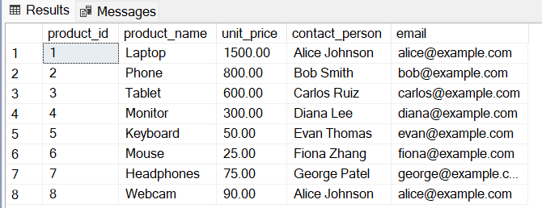

---Find all warehouses with their locations and capacities:

SELECT *

FROM Warehouse

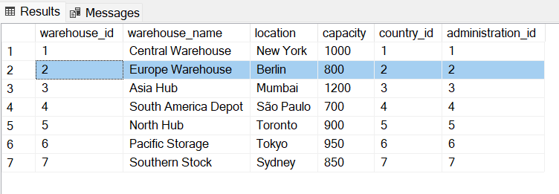

--List all employees with their supervisors

SELECT e.employee_name, s.supervisor_name

FROM Employees e,Supervisors s

where e.supervisor_id = s.supervisor_id

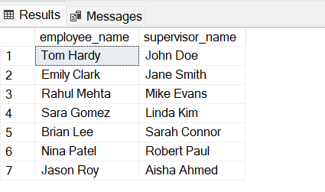

--Calculate the average salary by administration department

SELECT a.administration_name, AVG(e.salary) AS avg_employee_salary

FROM Employees e,Administration a

where e.administration_id = a.administration_id

GROUP BY a.administration_name;

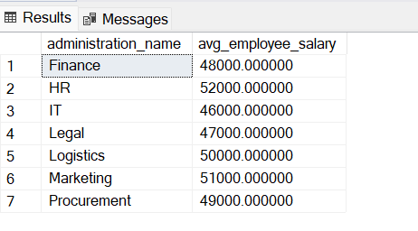

--Find products that are packaged in containers weighing more than 50 units:

SELECT p.product_name, pk.packaging_type, pk.weight_capacity

FROM Products p,Packaging pk

where p.packaging_id = pk.packaging_id and pk.weight_capacity > 50;

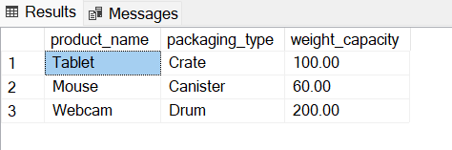

--Calculate the total tax for each country's import and export

SELECT country_name, import_tax, export_tax, (import_tax + export_tax) AS total_tax

FROM Countries

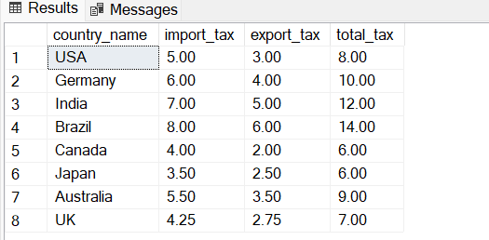

---Find all orders with their product details and customer countries:

SELECT o.order_id, o.order_date, p.product_name, p.unit_price, o.units, c.country_name

FROM Orders o JOIN Products p ON o.product_id = p.product_id

JOIN Countries c ON o.country_id = c.country_id;

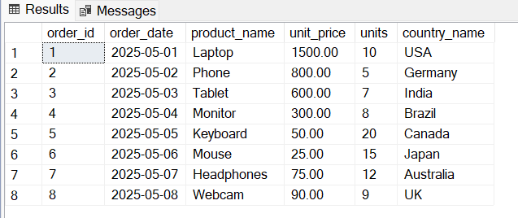

--List all employees who joined after their supervisors:

SELECT e.employee_name, e.joining_date AS employee_joined,

s.supervisor_name, s.joining_date AS supervisor_joined

FROM Employees e,Supervisors s

where e.supervisor_id = s.supervisor_id and e.joining_date > s.joining_date;

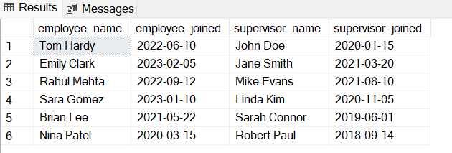

--Find warehouses that have capacity greater than the average capacity

SELECT w.warehouse_name, w.location, w.capacity

FROM Warehouse w

WHERE w.capacity >

(SELECT AVG(capacity) FROM Warehouse);

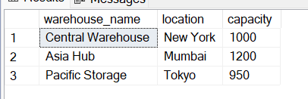

--Count the number of employees per supervisor:

SELECT s.supervisor_name, COUNT(e.employee_id) AS number_of_employees

FROM Supervisors s,Employees e Where s.supervisor_id = e.supervisor_id

GROUP BY s.supervisor_name

ORDER BY number_of_employees DESC;

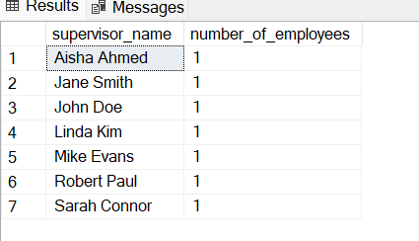

--Find all orders placed in May 2025

SELECT order_id, order_date, customer_id, product_id, units

FROM Orders

WHERE order_date BETWEEN '2025-05-01' AND '2025-05-31'

ORDER BY order_date;

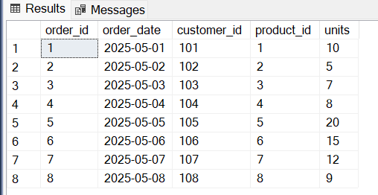

--Find all people (employees and supervisors) who work in the Logistics department:

SELECT e.employee_name AS name, 'Employee' AS role, e.email, e.phone_number

FROM Employees e

JOIN Administration a ON e.administration_id = a.administration_id

WHERE a.administration_name = 'Logistics'

UNION

SELECT s.supervisor_name AS name, 'Supervisor' AS role, s.email, s.phone_number

FROM Supervisors s

JOIN Administration a ON s.administration_id = a.administration_id

WHERE a.administration_name = 'Logistics'

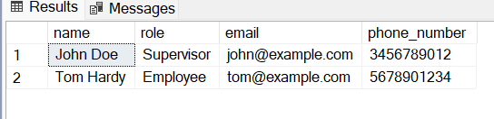

---List employees who aren't supervisors based on contact information

SELECT employee_name , email, phone_number

FROM Employees

EXCEPT

SELECT supervisor_name, email, phone_number

FROM Supervisors

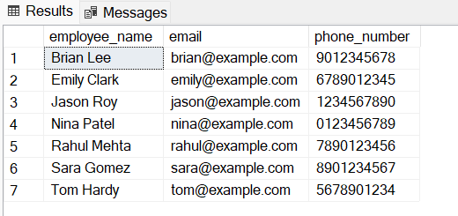

---Find employees and supervisors who share the same administration department

SELECT administration_id

FROM Employees

INTERSECT

SELECT administration_id

FROM Supervisors;

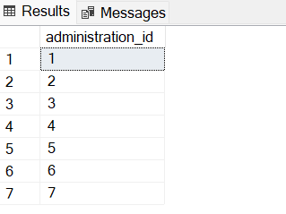

--Add a new supplier:

INSERT INTO Suppliers VALUES

(8, 'mahima', '23101030@uap-bd.edu', '01537479');

**7 .CEP Mapping**

Our project is a solution to a complex engineering problem because it can’t be resolved without in depth engineering knowledge. There is no obvious solution to and requires some amount of abstract thinking depending on the Database model. It also involves a diverse group of stakeholders with widely varying needs.

|  |  |  |  |  |
| --- | --- | --- | --- | --- |
| **K’s** | **Attributes** | **How K’s are addressed though our project** | **CO** | **PO** |
| **K3** | Engineering Fundamentals | Our Project involves a systematic formulation of engineering fundamentals like programming code, designing and problem solving. | CO1, CO2, CO3 | PO1, PO2 |
| **K5** | Engineering Design | We’ve made Entity-Relationship (ER) Diagram and Schema Diagram which are part of Engineering design. | CO3, CO4 | PO3, PO2 |
| K6 | Engineering Practice | We’ve implemented our design in MySQL. We created tables, inserted data with DDL and ran queries with DML. We’ve used MySQL workbench software as a tool for implementing our design. | CO1, CO2, CO5 | PO1 |

|  |  |  |  |  |
| --- | --- | --- | --- | --- |
| **P1** | Depth of knowledge required | The project requires us to study one of the fundamentals of engineering which is Database Management System design **(K3)**. It also requires designing ER and Schema diagram**(k5)** and implementing the design **(K6)**. | CO3,  CO4  CO5 | PO1,  PO2,  PO3,  PO7 |
| **P3** | Depth of analysis required | The designing and implementation differ for various kinds of businesses, so some amount of abstract thinking is necessary to formulate and analyze suitable models. | CO3,  CO5 | PO3 |
| **P7** | Interdependence | Our database has some subproblems or sections. Some of the table are related to orders and shipment of customers, some of the tables are related to orders and shipment of customers, some of the table are related to inventory and storing, some of the table are related to employees and supervisors of different administration, some table are for taxes and transactions. | CO3,  CO4  CO5 | PO2,  PO7 |

|  |  |  |  |  |
| --- | --- | --- | --- | --- |
| **A’s** | **Attributes** | **How A’s are addressed though are project** | **CO** | **PO** |
| **A1** | Range of resources | We needed various kinds of resources for this project such as Developers (US), Servicers and HDD Storage System (Laptop /Desktop), information about customers and trade licenses. | CO1 | P05 |
| **A5** | Familiarity | We had to get familiar with trade, economics and business operations besides engineering knowledge. | CO8,  C09 | P011 |

**END**